**2025 AVCA Division III Men’s Volleyball All-Americans**

**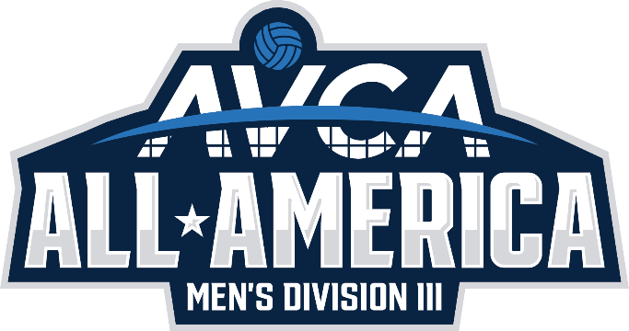***(Click links on names to see player bios)*

**First Team**

[Alex Kagoro](https://gomessiah.com/sports/mens-volleyball/roster/alex-kagoro/11325), Messiah University

[Andrew Kim](https://hwsathletics.com/sports/hobart-volleyball/roster/andrew-kim/22299), Hobart and William Smith Colleges

[Zach Knudsen](https://gonyuathletics.com/sports/mens-volleyball/roster/zach-knudsen/15144), New York University

[Corey Mayotte](https://duhawks.com/sports/mens-volleyball/roster/corey-mayotte/13851), Loras College

[Josh McLellan](https://athletics.aurora.edu/sports/mens-volleyball/roster/josh-mclellan/15126), Aurora University

[Dylan Mulvaney](https://springfieldcollegepride.com/sports/mens-volleyball/roster/dylan-mulvaney/12303), Springfield College

[Devyn Nguyen](https://gonyuathletics.com/sports/mens-volleyball/roster/devyn-nguyen/15147), New York University

[Lucas Osiecki](https://gonyuathletics.com/sports/mens-volleyball/roster/lucas-osiecki/15148), New York University

[Owen Otto](http://athletics.carthage.edu/sports/mens-volleyball/roster/owen-otto/15783), Carthage College

[Chris Rouleau](https://springfieldcollegepride.com/sports/mens-volleyball/roster/chris-rouleau/12310), Springfield College

[Christian Sheaffer](https://knightathletics.com/sports/mens-volleyball/roster/christian-sheaffer/8205), Southern Virginia University

[Koby Sherman](https://stevensducks.com/sports/mens-volleyball/roster/koby-sherman/17750), Stevens Institute of Technology

[Griffin Stella](https://sjfathletics.com/sports/mens-volleyball/roster/griffin-stella/13736), St. John Fisher University

[Theo Zaharewicz](https://laserpride.lasell.edu/sports/mvball/2024-25/bios/zaharewicz_theo_8hb5?view=profile), Lasell University

**Second Team**

[Michael Bowler](https://athletics.mountunion.edu/sports/mens-volleyball/roster/michael-bowler/13294), University of Mount Union

[Buddy Cohen](https://gonyuathletics.com/sports/mens-volleyball/roster/buddy-cohen/15135), New York University

[Jake DesLauriers](https://springfieldcollegepride.com/sports/mens-volleyball/roster/jake-deslauriers/12309), Springfield College

[Carter Durivage](https://springfieldcollegepride.com/sports/mens-volleyball/roster/carter-durivage/12299), Springfield College

[Emerson Evans](https://gonyuathletics.com/sports/mens-volleyball/roster/emerson-evans/15139), New York University

[Tyler Goldsborough](https://juniata.prestosports.com/sports/mvball/2024-25/bios/goldsborough_tyler_whig?view=bio), Juniata College

[Ben Heise](https://athletics.carthage.edu/sports/mens-volleyball/roster/ben-heise/15773), Carthage College

[Luke Hoffman](https://juniata.prestosports.com/sports/mvball/2024-25/bios/hoffman_luke_p56u?view=bio), Juniata College

[Ry Kagan](https://gonyuathletics.com/sports/mens-volleyball/roster/ry-kagan/15142), New York University

[Jared Piontkowski](https://athletics.misericordia.edu/sports/mens-volleyball/roster/jared-piontkowski/16175), Misericordia University

[Brandon Sharp](https://gomessiah.com/sports/mens-volleyball/roster/brandon-sharp/11330), Messiah University

[Michael Stahl](https://clusports.com/sports/mens-volleyball/roster/michael-stahl/7624), California Lutheran University

[Conner Stauffer](https://gomessiah.com/sports/mens-volleyball/roster/conner-stauffer/11331), Messiah University

[Gehrig Tolman](https://knightathletics.com/sports/mens-volleyball/roster/gehrig-tolman/8209), Southern Virginia University